[Predictors of Swimming Ability among Children and Adolescents in the United States - PMC](https://pmc.ncbi.nlm.nih.gov/articles/PMC5969197/)

3500 drowning deaths per year in US. Swimming ability is protective, but depends on access to swimming lessons and to a year-round pool.

[Swimming - NCHS Rapid Surveys System](https://www.cdc.gov/nchs/rss/round2/swimming.html)

Nov. 2023 CDC study of swimming skill in US found that 14% don’t know how to swim, only 32% can swim in water over head. Women and minorities are less likely to know how to swim.

[Vital Signs: Drowning Death Rates, Self-Reported Swimming Skill, Swimming Lesson Participation, and Recreational Water Exposure — United States, 2019–2023 | MMWR](https://www.cdc.gov/mmwr/volumes/73/wr/mm7320e1.htm)

Approximately 4,000 unintentional drowning deaths occur annually in the United States, and demographic disparities exist. The U.S. National Water Safety Action Plan provides recommendations for drowning prevention actions, including increasing access to basic swimming and water safety skills training for all persons, which could reduce disparities in unintentional drowning deaths.

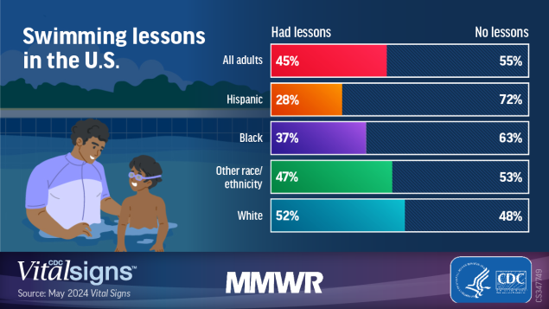

[Survey Finds Children, Teens Lack Basic Swim Safety Skills](https://www.redcross.org/about-us/news-and-events/press-release/survey-finds-children-teens-lack-basic-swim-safety-skills.html)

The survey, conducted for the Red Cross, found that nearly all parents (94 percent) expect that their children will engage in some sort of water activity this summer. However, nearly two-thirds (61 percent) of these parents report that their child cannot demonstrate all five basic skills that could save their lives in the water.

[Youth Swimming Ability and Associated Factors in the United State...: Ingenta Connect](https://www.ingentaconnect.com/content/png/ajhb/2018/00000042/00000005/art00003)

In 2017, fewer respondents reported no/low swimming ability. However, groups were identified with a high percentage (greater than 50%) of no/low swimming ability including the following ones; girls, African-American boys and girls, and boys and girls who participate in free or reduced-cost lunch programs.

[USA Swimming Foundation](https://www.usaswimming.org/foundation#overview)

* Drowning is the leading cause of unintentional death in the United States for children aged 1-4 and the second leading cause for children under the age of 14.
* One month of formal swimming lessons, which *reduces the risk of drowning in children by 88%*, can cost as little as $50 for children, and as little as $60 for adults. You can help provide the life-saving skill of swimming to persons of all ages!
* More than a third of adults in the U.S. can’t swim the length of a pool.